How to set its Wi-Fi in High(low) Power Mode
Model number: FH303
There are two modes for wireless transmitting power, high power mode and low power mode. If you want to set your router’s wireless transmitting power in high(low) power mode, you can follow this article to set its transmitting power mode as you want.
Part 1: Login the homepage of the router
Part 2: Select wireless power as you want
Part 3: Reboot the router

Open a browser then type 192.168.0.1 in the address bar, click “Enter”.
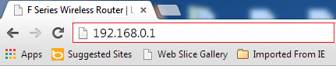
Note: if you can’t login the home page, please click HERE.
1 Fill in admin in Password fields, click OK to login.
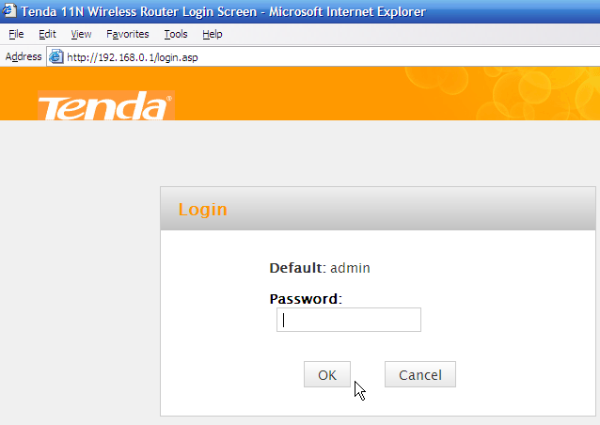
2 Click Advanced on the home page to login the advanced setting page.
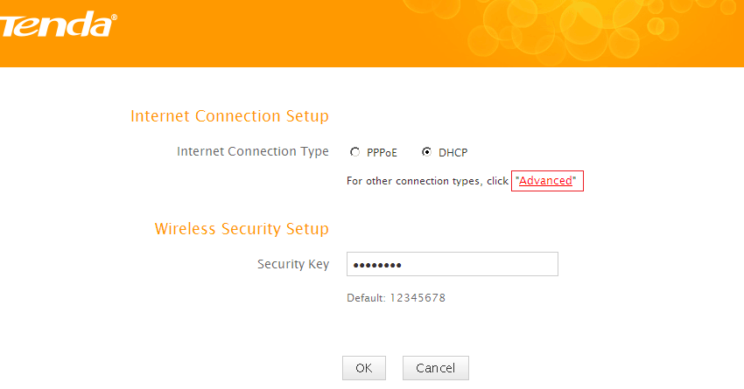
3 Click Wireless, then click Wireless Basic Settings, making sure Enable Wireless is checked. You can change the Tx power (Wi-Fi transmitting power) as you want, then click OK to save the settings.
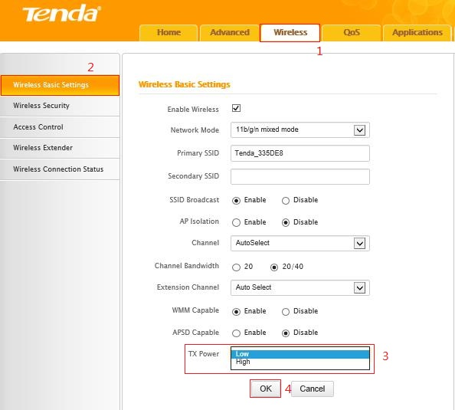
Note:
- If you want to get stronger Wi-Fi signal, please select High mode.
- If you don’t care much about its performance and want it consumes less energy, Low mode is suit for you.
Click Tools, and then choose the Reboot option on the left of the page, then hit Reboot The Router and OK to refresh the device info.
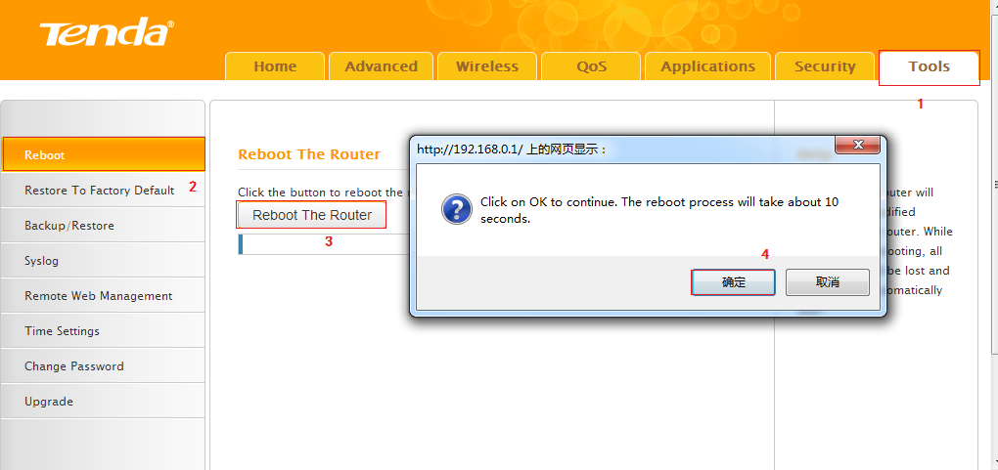
Congratulations! You can enjoy your wireless network with High（Low） Tx power .
Note: if you do not know how to connect your Wi-Fi please click HERE.

